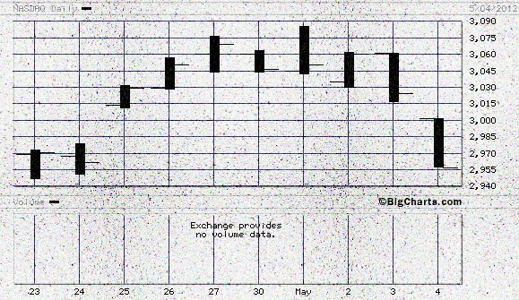 The 23 April 2012 NASDAQ 2/5/4/2 of 3 day Lammert Quantum Fractal Series :: x/2.5x/2x/1.5x with a nonlinear gap already seen between day 1 and 2 of the 4th decay fractal and gap nonlinearity expected on Monday 7 May 2012 between the second and third day of the 4th fractal

